Q. #Write a Python program to display a user-entered name followed by Good Afternoon using input() function

name=input("enter the name:")

print("Good Afternoon "+name)

output:

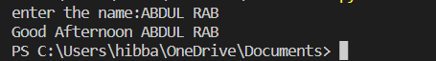

Q. #Write a program to fill in a letter template given below with name and date.

name=input("enter the name:")

print('''letter=\'\" Dear '''+name,'''

                        You are selected!

                        Date:14/10/22

''')

Output:

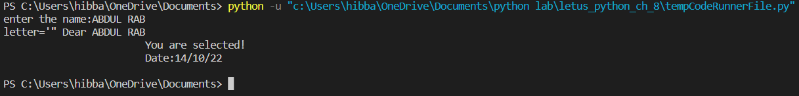

Q. #Write a program to detect double spaces in a string.

a=input("enter the any string:")

b=a.count("  ")

print("the double spaces in ",a," is ",b)

output:



Q. #Replace the double spaces from problem 3 with single spaces.

a.replace("  "," ")

print(a)

output:



Q.// #Write a program to format the following letter using escape sequence characters

print("letter=","\"Dear "+name,"This python course in nice.Thanks!!\"")

output:

